

JK LAKSHMIPAT UNIVERSITY

DIGITAL CIRCUIT AND SYSTEMS  
(EE1120)

Activity 06

BCD to seven segmented Decoder

Date : 29th February 2023

Name : Bobby Sharma

Roll no. = 2023BTECH023

AIM:Design 4- bit BCD to seven segmented decoder and show all output from 0 to 9 on display.

APPARATUS REQUIRED:

* Breadboard
* IC 4511
* Seven segmented displays
* Jumper wires
* Switches
* Resistors
* Battery

THEORY:

The decoder is an essential component in BCD to seven segment decoders. A decoder is nothing, but a combinational logic circuit mainly used for converting a BCD to an equivalent decimal number. It can be a BCD to seven segment decoders. A combinational logic circuit can be built with logic gates which include inputs as well as outputs. The output of this circuit mainly lies in the current condition of the inputs.

The best examples of this circuit are multiplexers, demultiplexers, adders, subtractors, encoders, decoders, etc. Figure 1 displays all the numbers in seven- segmented display.

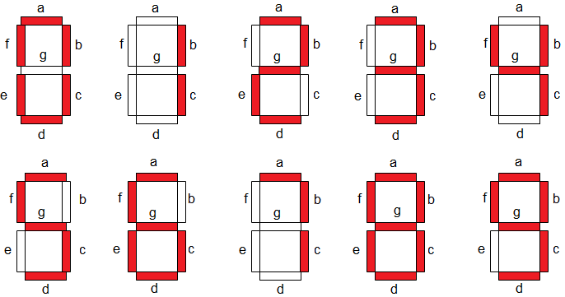

Figure 1

The circuit design, as well as operation, mainly depends on the concepts of Boolean algebra as well as logic gates. A seven segment LED display circuit can be built with eight LEDs. The common terminals are either anode otherwise cathode. A general cathode seven segment display includes 8 pins where 7-pins are input pins that are marked with from a to g & 8th-pin is a ground pin.

CIRCUIT DIAGRAM : The circuit connections are as follows:

* At First, one terminal of the switches is connected to source and the other terminal is connected to the resistors which is further connected to input pins number 1,2,6,7.
* After connecting all the resistors, switches to the input pins, pin 3,4 should connect to the source and pin 5 to ground (which is negative terminal of battery).
* Later, we will be connecting pin 8 and 16 to the ground and source respectively.
* Now, we will be connecting rest of the pins to the seven-segment display as stated in diagram

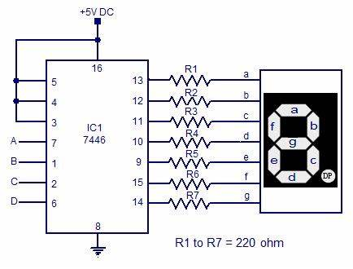

Figure 2

OBSERVATION: The observed output on seven- segment display are as follows:

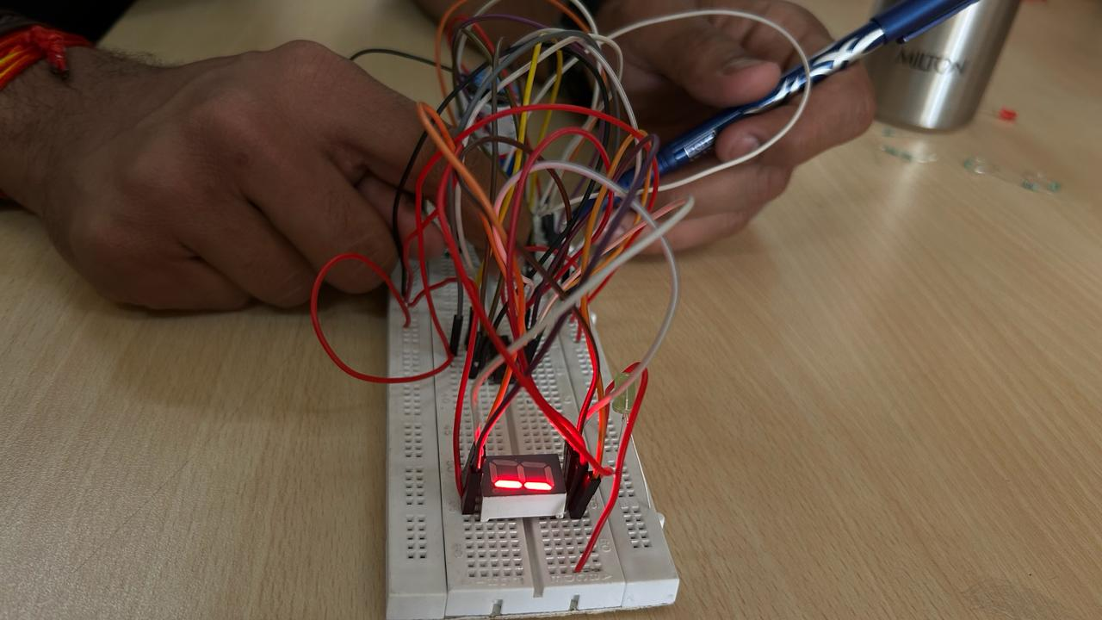 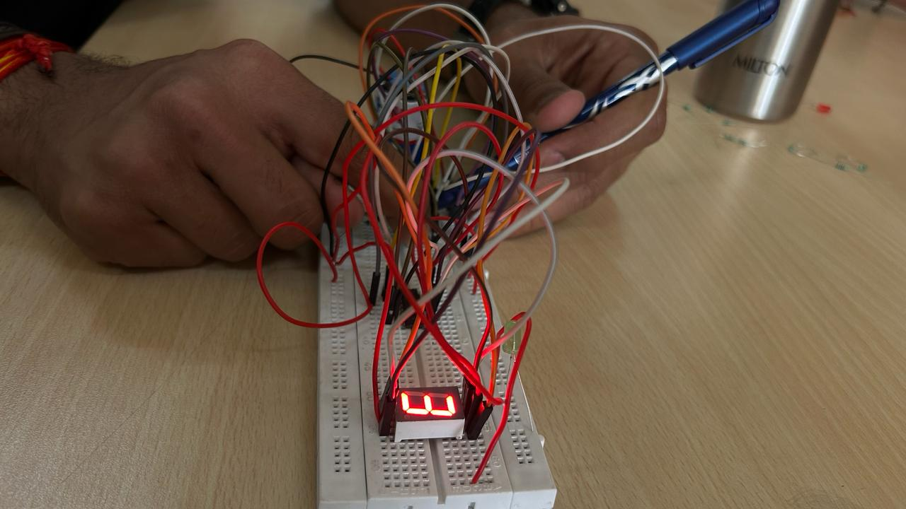

Figure 3 Figure 4

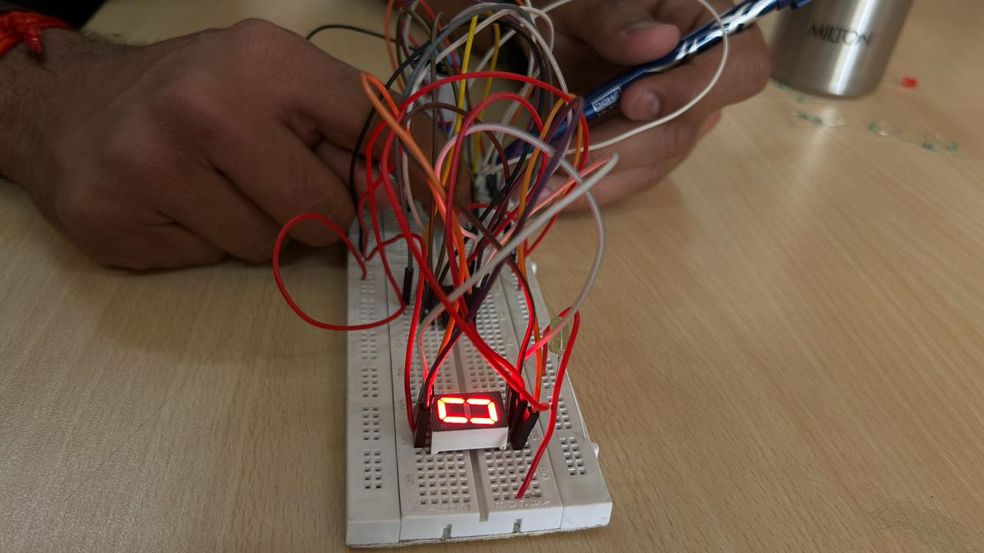 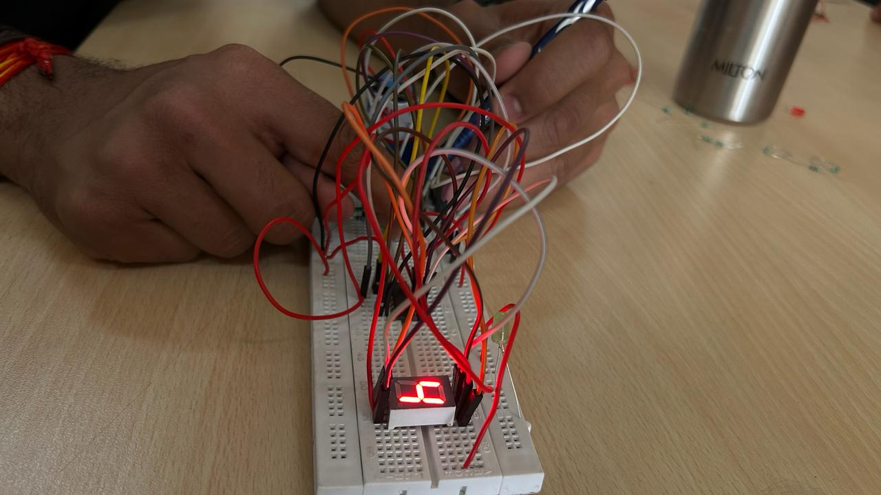

Figure 5 Figure 6

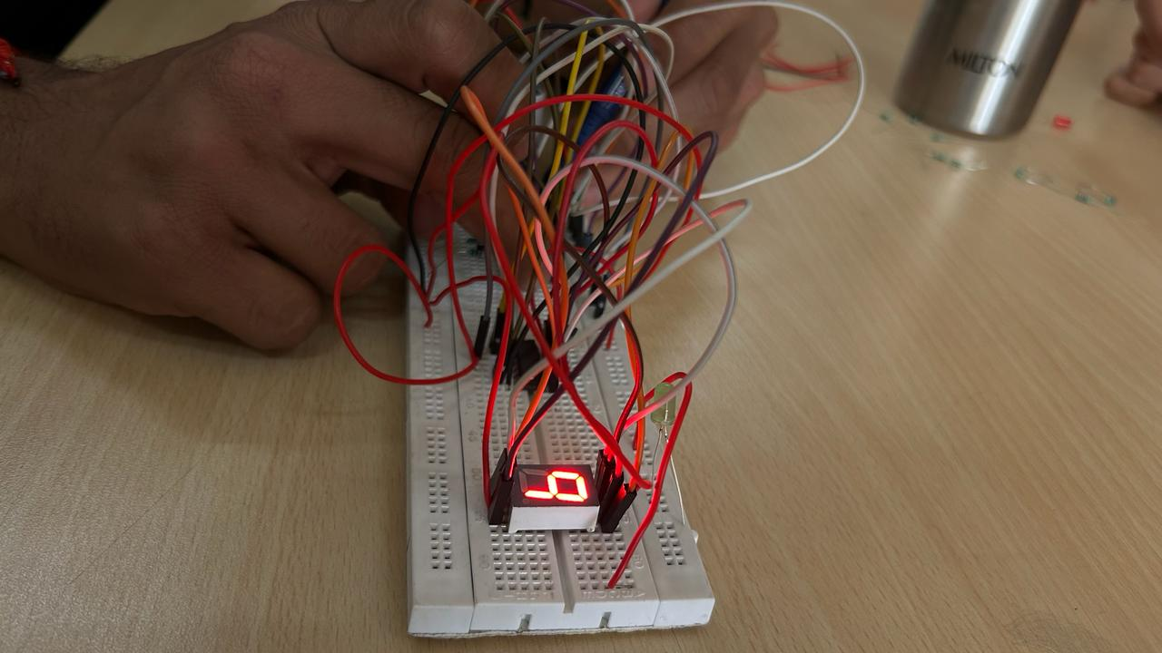 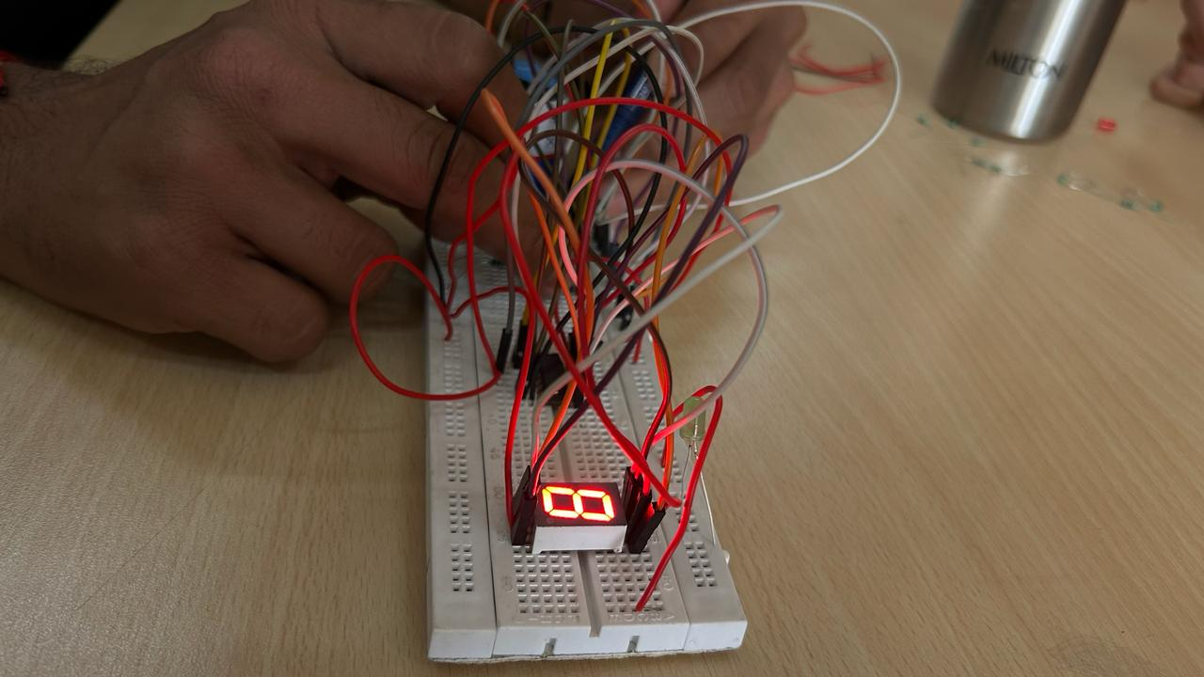

Figure 7 Figure 8

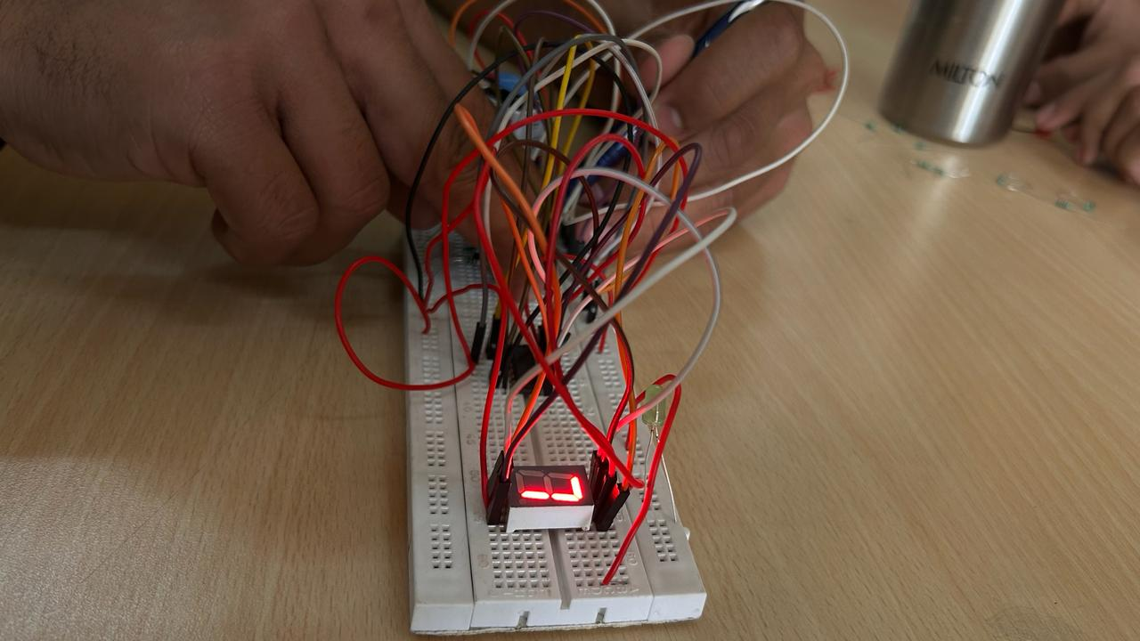 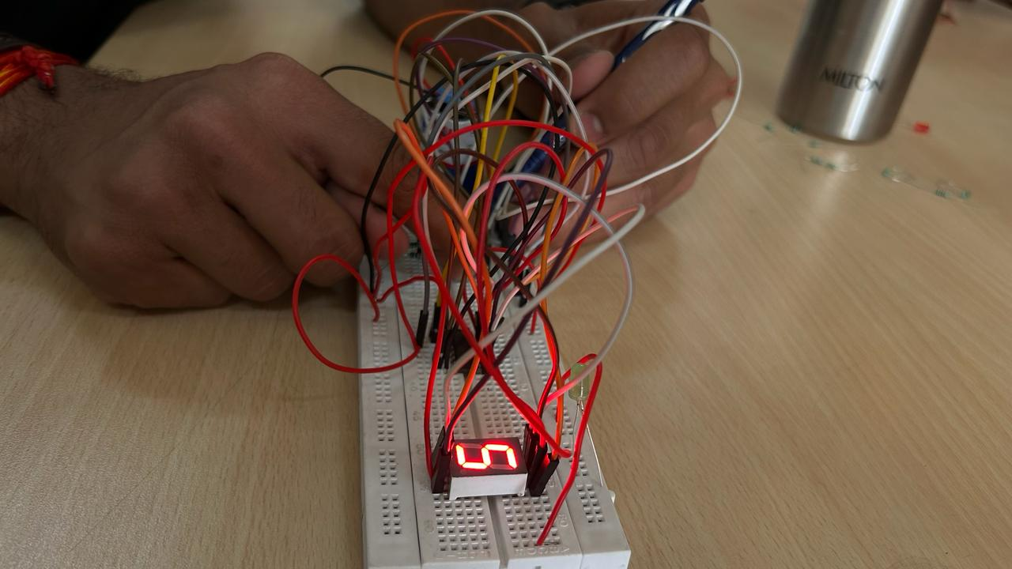

Figure 9 Figure 10

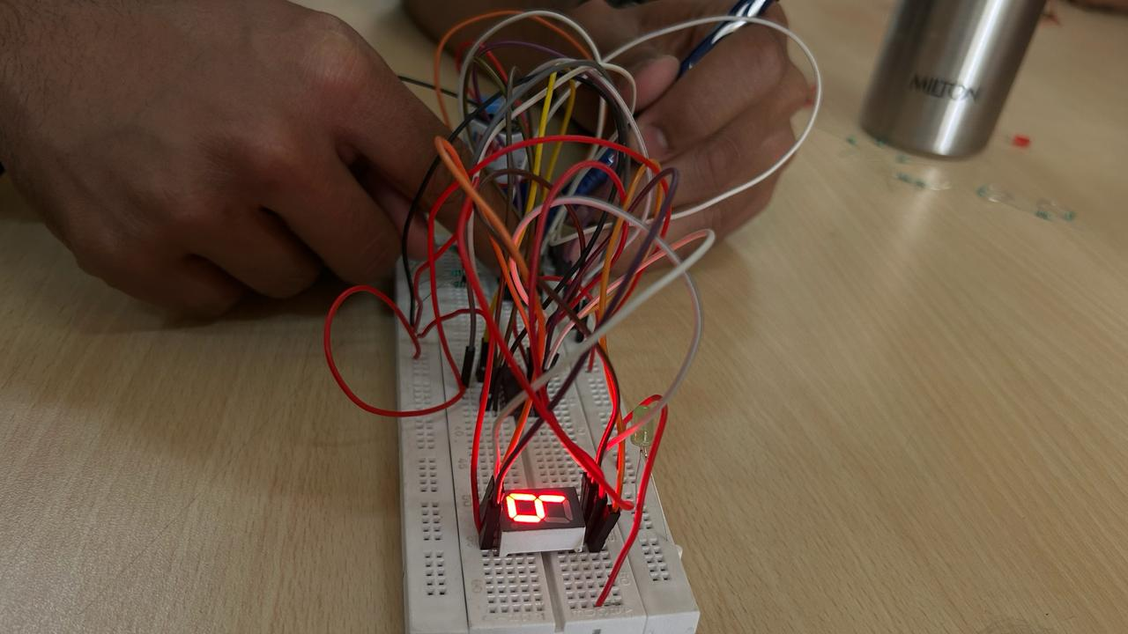

Figure 11

By this this observed output, we can easily form the truth table:

|  |  |  |  |  |  |  |  |  |  |  |
| --- | --- | --- | --- | --- | --- | --- | --- | --- | --- | --- |
| **x** | **y** | **z** | **w** | **a** | **b** | **c** | **d** | **e** | **f** | **g** |
| 0 | 0 | 0 | 0 | 0 | 0 | 0 | 0 | 0 | 0 | 1 |
| 0 | 0 | 0 | 1 | 1 | 0 | 0 | 1 | 1 | 1 | 1 |
| 0 | 0 | 1 | 0 | 0 | 0 | 1 | 0 | 0 | 1 | 0 |
| 0 | 0 | 1 | 1 | 0 | 0 | 0 | 0 | 1 | 1 | 0 |
| 0 | 1 | 0 | 0 | 1 | 0 | 0 | 1 | 1 | 0 | 0 |
| 0 | 1 | 0 | 1 | 0 | 1 | 0 | 0 | 1 | 0 | 0 |
| 0 | 1 | 1 | 0 | 0 | 1 | 0 | 0 | 0 | 0 | 0 |
| 1 | 1 | 1 | 1 | 0 | 0 | 0 | 1 | 1 | 1 | 1 |
| 1 | 0 | 0 | 0 | 0 | 0 | 0 | 0 | 0 | 0 | 0 |
| 1 | 0 | 0 | 1 | 0 | 0 | 0 | 1 | 0 | 0 | 0 |

RESULT: We have concluded the truth table observed from the display by connecting IC 4511 from seven segment decoders.

APPLICATION IN DAILY LIFE:

A Binary-Coded Decimal (BCD) to Seven-Segment Decoder is a digital circuit that converts a binary-coded decimal input (4 bits) into the corresponding 7-segment display output. Each decimal digit is represented by a 4-bit binary code, and the seven-segment display is a common way to visually represent numbers. Here's an example of a real-life application for a BCD to Seven-Segment Decoder:

* Digital Clocks and Timers: Many digital clocks and timers use BCD to Seven-Segment Decoders to convert the time information into a format that can be displayed on a seven-segment display. The hours and minutes are typically represented in BCD, and the decoder converts these codes into signals that illuminate the corresponding segments of the display.